**A Project Report**

**On**

**Crypto Trading Website**

Group No. 19

**Submitted by**

Prince Rathore (2104500100044)

Vansh K Tamta (2104500100063)

**Project Guide**

Prof. (Dr.) LS Maurya

Principal

**Submitted To**

Ms. Monica Mitra

(Project-In-Charge)



Department of Computer Science and Engineering

Shri Ram Murti Smarak of College of Engineering Technology and Research, Bareilly

DR. A.P.J. Abdul Kalam Technical University, Lucknow

FEB, 2024

**CONTENT**

* DECLARATION.........................................................................................................iii
* CERTIFICATE............................................................................................................iv
* ACKNOWLEDGEMENT...........................................................................................v
* ABSTRACT….............................................................................................................vi
* LIST OF FIGURES….................................................................................................vii

**CHAPTER 1**

* **1.1** INTRODUCTION..................................................................................................01
* **1.2** PROBLEM OF STATEMENTS………………..………………………………..02

**CHAPTER 2**

* **2.1** LITERATURE REVIEW.......................................................................................03

**CHAPTER 3**

* **3.1** PROPOSED WORK……………………..………………………………………06
* **3.2** TOOLS AND TECHNOLOGY……………..…………………………………...12
* **3.3** METHODOLOGY……………..………………………………………………...13
* **3.4** APPLICATIONS………...……...……………………………………………….14

**CHAPTER 4**

* **4.1** RESULT AND DISCUSSION…………………………………………………..15

**CHAPTER 5**

* **5.1** CONCLUSIONS………………………………………………………………...16
* **5.2** FUTURE ENHANCEMENT…………………………………………………....17
* **5.3** REFERENCES……………………………………………………………….….18

**DECLARATION**

I hereby declare that this submission is my own work and that, to the best of knowledge and belief, it contains no material previously published or written by another person nor material which to a substantial extent has been accepted for the award of any other degree or diploma of the university or other institute learning, except where due acknowledgement has been made in the text

Signature……………. Signature…………….

Name: Vansh K Tamta Name: Prince Rathore

Roll No.:2104500100063 Roll No.: 2104500100044

Date: Date:

**CERTIFICATE**

This is to certify that the Mini Project Report on“Crypto Trading Website” which is submitted by Prince Rathore (2104500100044), Vansh K Tamta (2104500100063), is a record of the candidates own work is original and has not been submitted for the award of any other work or degree.

Ms. Monika Mitra Prof. (Dr.) LS Maurya

Project In-charge (CSE) Project-guide

**ACKNOWLEDGEMENT**

It gives us a great sense of pleasure to present the report of the B. Tech Mini Project undertaken during B. Tech. Second Year. We owe special debt of gratitude to **Ms. Monica Mitra (Assistant Professor)**, Computer Sciences And Engineering, S.R.M.S C.E.T&R, Bareilly for his constant support and guidance throughout the course of our work. His sincerity, thoroughness and perseverance have been a constant source of inspiration for us. It is only his cognizant efforts that our endeavours have seen light of the day.

We also take the opportunity to acknowledge the contribution of **Prof. DR. L. S. Maurya, Principa**l, S.R.M.S CET&R, Bareilly for his full support and assistance during the development of the project.

We also do not like to miss the opportunity to acknowledge the contribution of all faculty members of the department for their kind assistance and cooperation during the development of our project. Last but not the least, we acknowledge our friends for their contribution in the completion of the project.

Signature……………. Signature…………….

Name: Vansh K Tamta Name: Prince Rathore

Roll No.:2104500100063 Roll No.: 2104500100044

Date: Date:

**ABSTRACT**

The project “Crypto Trading Website” report explores the development and deployment of a cryptocurrency trading website with a focus on providing users with a seamless and secure trading experience. The objective is to analyze the intricacies of crypto trading platforms, understand user requirements, and implement features that enhance usability, security, and overall satisfaction.

The report begins with a thorough review of existing crypto trading websites, identifying their strengths and weaknesses. It delves into the evolving landscape of the cryptocurrency market, highlighting key trends, challenges, and opportunities. The project's emphasis on a user-centric approach involves conducting surveys and interviews to gather insights into the preferences and concerns of potential users.

The design phase involves the creation of an intuitive and responsive user interface, ensuring accessibility across various devices. Security measures, including encryption protocols and multi-factor authentication, are implemented to safeguard user assets and personal information. Smart contract integration and blockchain technology are leveraged to enhance transparency and trust in the trading process.

The implementation phase covers the development of essential features such as real-time market data, order execution, portfolio tracking, and risk management tools. The website is designed to support a wide range of cryptocurrencies, providing users with diverse trading options. Additionally, the integration of analytical tools and trading indicators enhances users' decision-making capabilities.

**LIST OF FIGURES**

* FIG 1. HOME PAGE
* FIG 2. CRYPTO CONVERTER
* FIG 3. CRYPTO NEWS
* FIG 4. TIME DURETION PAGE
* FIG 5. ROADMAP PAGE

**CHAPTER-1**

**1.1 INTRODUCTION**

In recent years, the tendency of the number of financial institutions to include cryptocurrencies in their portfolios has accelerated. Cryptocurrencies are the first pure digital assets to be included by asset managers. Although they have some commonalities with more traditional assets, they have their own separate nature and their behaviour as an asset is still in the process of being understood. It is therefore important to summarise existing research papers and results on cryptocurrency trading, including available trading platforms, trading signals, trading strategy research and risk management. This paper provides a comprehensive survey of cryptocurrency trading research, by covering 146 research papers on various aspects of cryptocurrency trading (*e*.*g*., cryptocurrency trading systems, bubble and extreme condition, prediction of volatility and return, crypto-assets portfolio construction and crypto-assets, technical trading and others). This paper also analyses datasets, research trends and distribution among research objects (contents/properties) and technologies, concluding with some promising opportunities that remain open in cryptocurrency trading.

Cryptocurrencies have experienced broad market acceptance and fast development despite their recent conception. Many hedge funds and asset managers have begun to include cryptocurrency-related assets into their portfolios and trading strategies. The academic community has similarly spent considerable efforts in researching cryptocurrency trading. This paper seeks to provide a comprehensive survey of the research on cryptocurrency trading, by which we mean any study aimed at facilitating and building strategies to trade cryptocurrencies.

As an emerging market and research direction, cryptocurrencies and cryptocurrency trading have seen considerable progress and a notable upturn in interest and activity (Farell[2015](https://link.springer.com/article/10.1186/s40854-021-00321-6" \l "ref-CR114)). From Fig. [1](https://link.springer.com/article/10.1186/s40854-021-00321-6" \l "Fig1), we observe over 85% of papers have appeared since 2018, demonstrating the emergence of cryptocurrency trading as a new research area in financial trading. The sampling interval of this survey is from 2013 to June 2021.

**1.2 PROBLEM STATEMENT**

Cryptocurrencies forever changed the idea of personal finance and doing business. Over the years, they cause controversy, are criticized, give rise to crime, are accompanied by failures, and make it possible to earn good money.

1. Malware: The first of them were created at the time of the advent of electronic payment systems. Now their counterparts are adapted to the cryptocurrency market and can be activated wherever such an opportunity arises.
2. Hackers Attack: Cyberattacks are the second largest problem and a frequent occurrence in the world of developing cryptocurrencies.
3. Bankruptcy and closure of exchanges: Over the previous 5 years, about 48% of cryptocurrency exchanges have been closed, among which quite promising were present.
4. Volatility=Volatility: The unpredictable jumps in the exchange rate are partly due to the limited release of the “king of cryptocurrencies” – 21 million bitcoins. Each of them is growing daily in price, increasing demand.
5. Spoofing payment information and phishing: As with ordinary e-money, users can be tricked into going to a phishing website where they upload their cryptowallets and enter a password.
6. Energy consumption: Bitcoin's proof-of-work consensus algorithm requires a significant amount of energy to maintain the network, raising concerns about its environmental impact.

**CHAPTER-2**

**2.1 LITERATURE REVIEW**

A literature review for cryptocurrency trading would typically involve an analysis of academic and professional research articles, papers, and books related to the subject. Below, I'll provide an overview of key topics and findings often explored in the literature on cryptocurrency trading:

1. **3commas: 3Commas Smart Trading terminal and auto trading bots. https://3commas.io/. [Online, Accessed 26 Jan 2020] (2020):** To get an effective trading result, traders need a strategy and high-quality software to implement it. To achieve this perfection, we create tools for trading on Binance that help many traders around the world.We recommend to use only proven trading services. We have been working with Binance since 2017, in October 2019 we became official partners. Trading bots helps users grow their cryptocurrency investments using a feature-rich terminal and proven automated bots that take full advantage of the Binance exchange platform. For every market condition, there’s a trading strategy that can profit from it. 3Commas bots happen to be really good at reducing average acquisition costs, directly increasing your profit margins from each trade.
2. **What crypto exchanges do to comply with KYC, AML and CFT regulations. https://cointelegraph.com/news/what-crypto-exchanges-do-to-comply-with-kyc-aml-and-cft-regulations. [Online, Accessed January 11, 2020] (2019):** Exchanges are simply an important component of the system that makes the crypto market tick. Regulators around the world have [identified](https://www.reuters.com/article/uk-markets-bitcoin/bitcoin-other-cryptocurrencies-tumble-on-government-crackdown-worries-idUSKBN1F50UV" \t "https://cointelegraph.com/news/_blank) this, which is why regulatory moves have primarily targeted exchanges. Regulators want to be sure that exchanges employ the best security practices as well as measures — Know Your Customer ([KYC](https://cointelegraph.com/tags/kyc)). Some exchanges do take their compliance to those measures seriously. For example, in the aftermath of the [Binance hack](https://cointelegraph.com/news/hackers-withdraw-7-000-bitcoins-in-binance-crypto-exchange-security-breach) on May 7, when around 7,074 bitcoins (worth $40 million on the day) were stolen, the company’s founder and CEO, Changpeng Zhao, [announced](https://www.binance.com/en/blog/333497959022997504/Binance-Security-Incident-Update" \t "https://cointelegraph.com/news/_blank) that a significant security update will be conducted that will also include an upgrade to the KYC measures:

**“We are making significant changes to the API, 2FA, and withdrawal validation areas, which was an area exploited by hackers during this incident. We are improving our risk management, user behavior analysis, and KYC procedures.”**

[Know Your Customer](https://complyadvantage.com/knowledgebase/kyc/" \t "https://cointelegraph.com/news/_blank), refers to a set of procedures and process that a company employs to confirm the identity of its user or customer. The robustness of KYC procedures varies across companies and jurisdictions. However, KYC fundamentally involves the collection and verification of a customer’s means of identification — including government-issued identity cards, phone numbers, a physical address, an email address and a utility bill, to name a few.

1. **Delfabbro, P., King, D., Williams, J., & Georgiou, N. (2021). Cryptocurrency trading, gambling and problem gambling. Addictive Behaviors, 122, Article 107021. <https://doi.org/10.1016/j.addbeh.2021.107021:>** Some forms of speculative trading share similarities with gambling. Decisions are often based on limited information, short-term motives for gain, and highly volatile and uncertain outcomes. Given these similarities, there is evidence to show that people who are attracted to gambling are also statistically more likely to engage in higher risk speculation such as day-trading of stocks and crypto-currency trading. In this study, involving 543 people (M = 388, F = 155, 85% aged 18–40 years) who reported at least monthly sports-betting, crypto-currency trading or both, we examined whether gambling and problem gambling were reliable predictors of the reported intensity of crypto-currency trading. The results showed that gambling and problem gambling rates were highest among those who reported both activities and that problem gambling scores (PGSI) and engaging in stock trading was significantly related to measures of crypto-currency trading intensity as based on the time spent per day, number of trades and level of expenditure. Future research should examine whether gambling history and involvement influences how people manage their investments in crypto-currencies, including their propensity for making riskier decisions and experiencing more negative outcomes.

**CHAPTER-3**

**3.1 HOME PAGE**



FIG 1. HOME PAGE

**3.1.1 CRYPTO CONVERTOR**

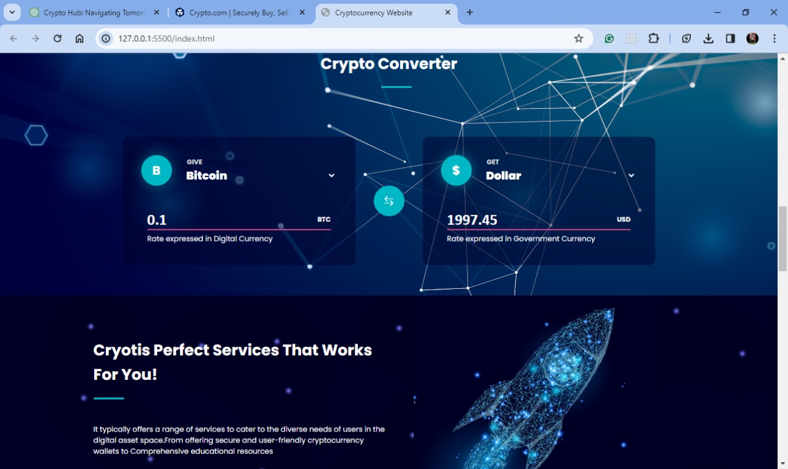

FIG 2. Converter

**3.1.2 Crypto news**

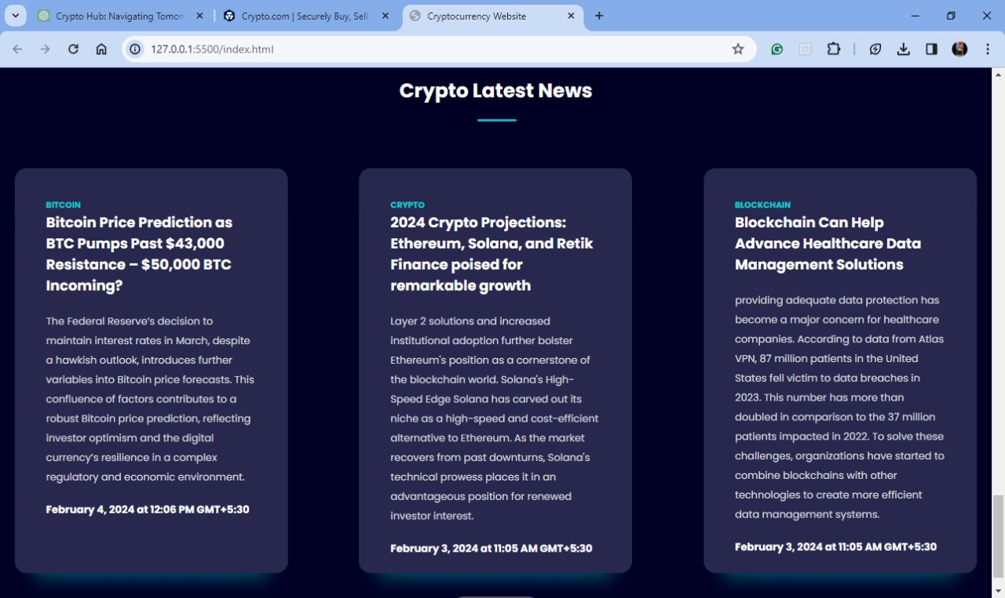 FIG 3. News

**3.1.2 Timer**

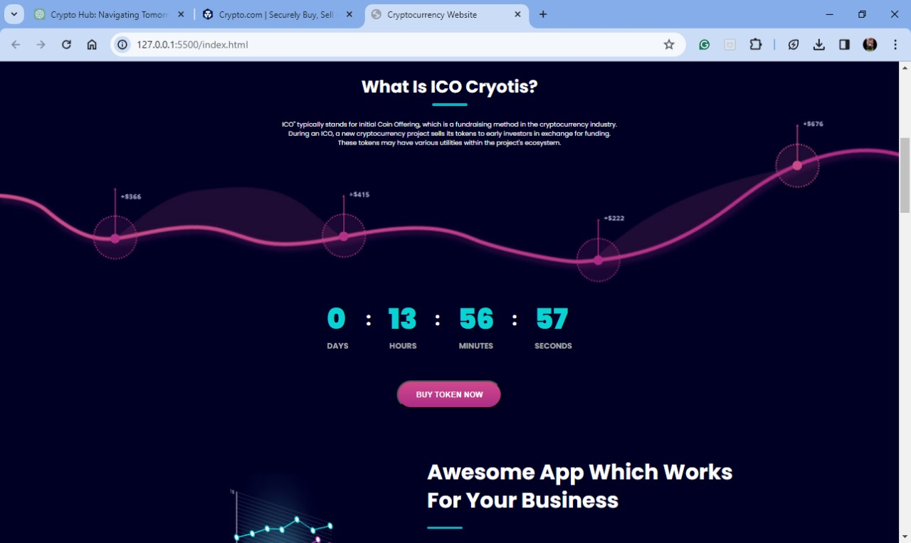

FIG 4. Time duration page

**3.1.3 Road Map**

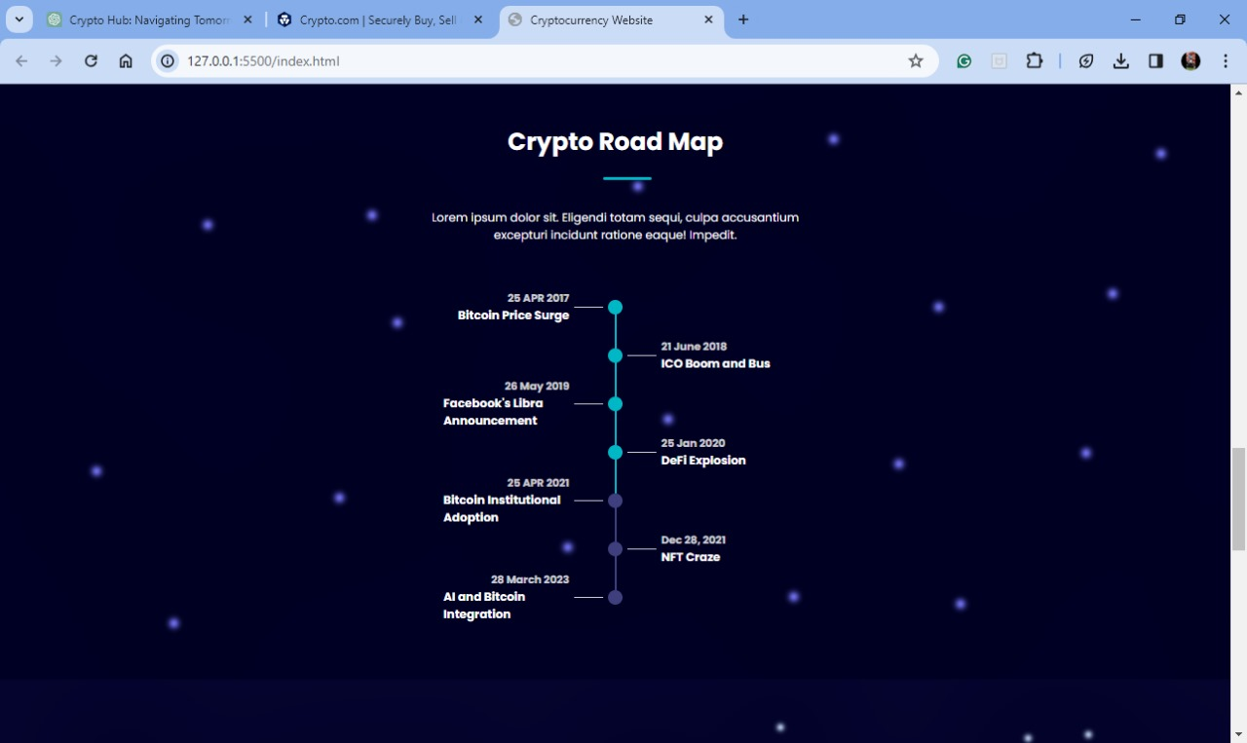

FIG 5. Roadmap page

**3.2 TOOLS AND TECHNOLOGY**

* HTML –

Its stands for Hyper Text Markup Language, is the standard markup language used to create web pages and structure the content on the world wide web.

* CSS –

Cascading Style Sheets, It allows developers to define how HTML elements should be displayed on a web page, including aspects like colors, fonts, spacing, positioning and responsiveness.

* JavaScript –

It allows us to add interactivity, dynamic behavior, and advanced features to web pages. JavaScript is an essential technology for creating modern, interactive websites and web applications.

* Django –

It is a python web framework that enables rapid development of secure and maintainable websites.

**3.3 METHODOLOGY**

There are 5 steps to trade Cryptocurrency safely on the internet and here’s the graphical representation of the methodology to do the same:

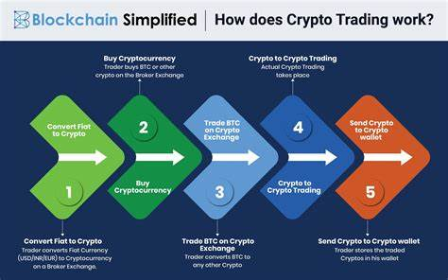

**Fig: Data-Flow Diagram**

Crypto trading can be highly speculative and risky, and it's important to approach it with caution and a well-thought-out strategy. Here's a five-step methodology for crypto trading:

1. Education and Research: Before you start trading, it's crucial to educate yourself about the cryptocurrency market. Understand the basics of blockchain technology, how cryptocurrencies work, and the different types of cryptocurrencies available. Stay updated on market news, trends, and developments in the crypto space. Join online forums, follow influential figures on social media, and read reputable crypto news sources.
2. Choose a Reliable Exchange: Select a reputable cryptocurrency exchange to trade on. Ensure it has a good track record for security, user experience, and customer support.Consider factors like available trading pairs, fees, and liquidity. Different exchanges offer different trading options, so choose one that aligns with your goals and preferences.
3. Risk Management: Determine your risk tolerance and set clear risk management strategies. Only invest what you can afford to lose. Cryptocurrency markets can be extremely volatile, and prices can change rapidly. Consider using stop-loss and take-profit orders to limit potential losses and lock in profits.
4. Technical and Fundamental Analysis: Analyze cryptocurrencies using both technical and fundamental analysis. Technical analysis involves studying price charts, patterns, and indicators to make trading decisions.Fundamental analysis involves evaluating the underlying technology, team, adoption, and real-world use cases of a cryptocurrency. This can help you make informed investment decisions.
5. Develop a Trading Plan: Create a well-defined trading plan that includes your entry and exit points, risk-reward ratios, and overall trading strategy.Stick to your plan, and avoid making impulsive decisions based on emotions. Greed and fear can lead to significant losses in the crypto market.
6. Continuous Learning and Adaptation: Crypto markets are highly dynamic. Continuously update your knowledge and adapt your trading strategy as the market evolves.Keep a trading journal to track your trades, successes, and mistakes. Analyzing your past performance can help you improve your future decisions.
7. Security:Prioritize the security of your crypto assets. Use hardware wallets or secure software wallets to store your cryptocurrencies when you're not actively trading. Enable two-factor authentication on your exchange accounts.

**3.4 APPLICATIONS**

Cryptocurrency has a variety of applications across different industries and sectors. Here are some notable applications:

* **Decentralized Finance (DeFi):** Cryptocurrencies enable the creation of decentralized financial systems, offering services such as lending, borrowing, and trading without the need for traditional financial intermediaries like banks.
* **Cross-Border Payments:** Cryptocurrencies facilitate faster and cheaper cross-border transactions compared to traditional banking systems. They eliminate the need for intermediaries and reduce transaction fees and processing times.
* **Smart Contracts:** Cryptocurrencies like Ethereum support the development and execution of smart contracts, which are self-executing contracts with the terms of the agreement directly written into code. This automation streamlines and enhances the efficiency of various processes.
* **Tokenization of Assets:** Assets like real estate, art, and even stocks can be tokenized on blockchain platforms. This allows for easier fractional ownership, increased liquidity, and more efficient trading of traditionally illiquid assets.
* **Supply Chain Management:** Blockchain and cryptocurrency can be used to enhance transparency and traceability in supply chains. This is particularly useful in industries like food and pharmaceuticals, where the origin and history of products are critical.
* **Identity Verification:** Cryptocurrencies can contribute to secure and decentralized identity verification systems. Individuals can control and share their personal information without relying on a centralized authority, enhancing privacy and reducing the risk of identity theft.
* **Remittances:** Cryptocurrencies provide an efficient and cost-effective solution for remittances, enabling individuals to send money across borders with lower fees and quicker settlement times.
* **Crowdfunding and Fundraising:** Initial Coin Offerings (ICOs) and Security Token Offerings (STOs) enable startups and projects to raise capital directly from the public, democratizing access to funding.
* **Gaming and Virtual Assets:** Cryptocurrencies are used in the gaming industry for in-game purchases, as well as the creation and trading of virtual assets. Blockchain technology ensures ownership and scarcity of digital items.
* **Privacy and Anonymity:** Some cryptocurrencies, like Monero and Zcash, focus on providing enhanced privacy features, allowing users to make transactions with a higher degree of anonymity.
* **Voting Systems:** Blockchain technology can be applied to create secure and transparent voting systems, reducing the risk of fraud and manipulation in elections.
* **Insurance and Risk Management:** Cryptocurrencies and smart contracts can be utilized in the insurance industry to automate claims processing, streamline underwriting, and improve overall transparency.

**CHAPTER-4**

**4.1 RESULT AND DISCUSSION**

Result:Our examination of [Cryptocurrency Website Name] has provided insights into various aspects of the platform, shedding light on its strengths and areas for improvement.

* User interface and Experience: The website showcases a well-designed and user-friendly interface. Navigation is intuitive, and the overall user experience is commendable. The design elements contribute to a visually appealing and accessible platform.
* Trading Features: [Cryptocurrency Website Name] offers a diverse range of trading features, including real-time market data, advanced charting tools, and order execution options. The trading interface is robust, catering to the needs of both beginners and experienced traders.
* Security Measures: Security is a priority for [Cryptocurrency Website Name]. The implementation of two-factor authentication and encryption instills confidence in the protection of user assets. The platform's commitment to user security is evident in its measures against potential threats.
* Educational Resources: The platform provides a wealth of educational resources, from basic guides to in-depth analyses. This commitment to user education sets [Cryptocurrency Website Name] apart as a platform that values empowering its user base

Discussion:

* Strengths: The user-friendly interface and robust trading features contribute to a positive user experience. The platform's commitment to security and education aligns with the evolving needs of the cryptocurrency community.
* Area of Improvement: While the educational resources are comprehensive, there is an opportunity to enhance their accessibility and organization for users at different experience levels. Improving the onboarding process could further enhance the platform's appeal to newcomers.
* Future Development: “ICO CRYPTOS” has a strong foundation, and future development could focus on scalability, additional trading pairs, and further community-building initiatives. Staying responsive to user feedback and market trends will be crucial for sustained growth.

**CHAPTER-5**

**5.1 CONCLUSIONS**

In conclusion, the cryptocurrency trading website represents a pivotal player in the dynamic landscape of digital asset markets. With its user-friendly interface, robust security measures, and an array of features, the platform strives to provide traders with a seamless and efficient experience. The integration of cutting-edge technologies, such as blockchain, ensures transparency, immutability, and trust in transactions.

The website's commitment to compliance with regulatory standards, coupled with continuous innovation, positions it as a reliable and forward-thinking solution for both novice and experienced traders. As cryptocurrencies continue to gain mainstream acceptance, the trading website serves as a gateway to the decentralized financial ecosystem, offering a diverse range of assets and investment opportunities.

However, it is essential for users to exercise diligence and adhere to responsible trading practices, given the inherent volatility of cryptocurrency markets. The website's educational resources and risk management tools play a crucial role in empowering users to make informed decisions and navigate the complexities of digital asset trading.

Ultimately, the cryptocurrency trading website plays a pivotal role in the broader adoption and acceptance of digital currencies, contributing to the democratization of finance and reshaping the way individuals engage with global markets. As the cryptocurrency space evolves, the platform remains poised to adapt and grow, meeting the ever-changing needs of the trading community.

**5.2 FUTURE ENHANCEMENT**

1. **Advanced Trading Algorithms:**
   * Implement sophisticated trading algorithms and machine learning models to offer users automated trading strategies.
   * Provide options for algorithmic trading, including trend analysis, arbitrage opportunities, and sentiment analysis.
2. **Integrated Social Trading:**
   * Integrate social features, allowing users to follow and copy the trades of successful and experienced traders.
   * Enable a social trading community where users can share insights, strategies, and market analyses.
3. **Liquidity Aggregation:**
   * Enhance liquidity by aggregating data from multiple exchanges, ensuring the best possible execution prices for users.
   * Implement a liquidity pool that facilitates seamless trading across various cryptocurrencies and trading pairs.
4. **Mobile App Development:**
   * Develop a dedicated mobile application for iOS and Android platforms to provide users with on-the-go access to their accounts and the crypto markets.
   * Optimize the app for a smooth and intuitive mobile trading experience.
5. **Staking and Yield Farming Integration:**
   * Integrate staking and yield farming functionalities, allowing users to earn passive income by participating in various decentralized finance (DeFi) opportunities.
   * Provide users with options to stake their assets directly from the platform.
6. **Expanded Asset Support:**
   * Continuously add support for new and emerging cryptocurrencies and tokens, ensuring users have access to a diverse range of assets.
   * Integrate popular decentralized finance (DeFi) tokens to align with the evolving crypto market trends.
7. **Educational Resources:**
   * Develop an educational portal or resource center within the platform to help users enhance their understanding of crypto markets, trading strategies, and blockchain technology.
   * Provide tutorials, webinars, and articles to empower users with the knowledge needed for successful trading.
8. **Enhanced Security Measures:**
   * Stay proactive in implementing the latest security measures, including biometric authentication, hardware wallet integration, and real-time threat monitoring.
   * Collaborate with cybersecurity experts to conduct regular audits and ensure the platform's resilience against emerging security threats.
9. **Regulatory Compliance Updates:**
   * Stay abreast of evolving regulatory frameworks and ensure continuous compliance with global and local regulations.
   * Establish partnerships with regulatory bodies and implement features that facilitate adherence to regulatory requirements.
10. **Community Engagement Features:**
    * Introduce features that enhance community engagement, such as discussion forums, AMA (Ask Me Anything) sessions with industry experts, and community-driven initiatives.
    * Encourage user feedback and implement community-suggested enhancements to improve the platform's overall user experience.

These future enhancements aim to position the crypto trading website as a dynamic and evolving platform that not only meets the current needs of users but also adapts to the changing landscape of the cryptocurrency market. Regular updates and innovations will be crucial for maintaining competitiveness and ensuring user satisfaction.

**REFERENCES**

1. 3commas: 3Commas Smart Trading terminal and auto trading bots. https://3commas.io/. [Online, Accessed 26 Jan 2020] (2020)
2. What crypto exchanges do to comply with KYC, AML and CFT regulations. https://cointelegraph.com/news/what-crypto-exchanges-do-to-comply-with-kyc-aml-and-cft-regulations. [Online, Accessed January 11, 2020] (2019).
3. Delfabbro, P., King, D., Williams, J., & Georgiou, N. (2021). Cryptocurrency trading, gambling and problem gambling. Addictive Behaviors, 122, Article 107021. https://doi.org/10.1016/j.addbeh.2021.107021
4. Delfabbro P, King DL, Williams J (2021) The psychology of crypto currency trading: Risk and protective factors. J Behav Addict.
5. Forbes: Is The Crypto Market Maturing? An Analysis For Entrepreneurs. https://www.forbes.com/sites/theyec/2021/06/01/is-the-crypto-market-maturing-an-analysis-for-entrepreneurs/?sh=1170160bba22. [Online, Accessed: June 1, 2021] (2021)
6. https://jfin-swufe.springeropen.com/articles/10.1186/s40854-021-00321-6
7. .https://coinpedia.org/guest-post/8-problems-and-risks-of-cryptocurrencies/